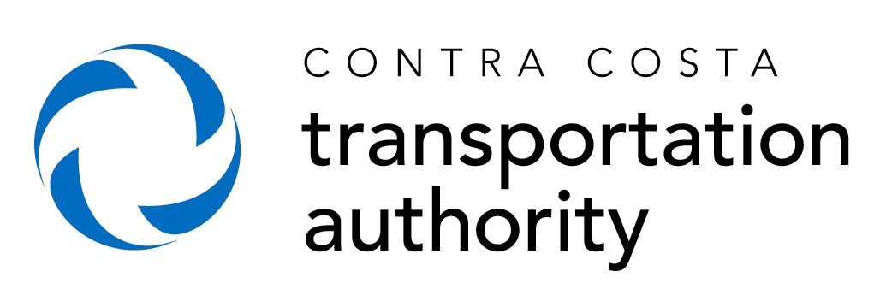

ANNUAL REPORTING FORM
for MEASURE J LOCAL STREET MAINTENANCE AND IMPROVEMENTS (LSM) FUNDS
(18% LSM FUNDS & 2.09% ADDITIONAL FUNDS)
FOR ELIGIBLE EXPENDITURES DURING FISCAL YEAR 2020-21

Jurisdiction: ______________________________________

If you have any questions regarding this form, please contact Matt Kelly at CCTA, mkelly@ccta.net.
Please return the form to CCTA, along with the LSM Audit Reporting Form spreadsheet, Attn: Jackie Reyes (at address listed below or jreyes@ccta.net)

Total for FY 2020-21
Starting Balance as of July 1, 2020
18% + 2.09% Funds Received during FY 2020-21 (actual, not accrued)
LSM Eligible Expenditures (Please describe all expenditures in excess of
$10,000 on the LSM Audit Reporting spreadsheet)
Local Street and Roads
Growth Management Planning and Compliance
Transit Capital and Operations
Trails
Parking Facilities
Transportation Demand Management/Transportation Systems Management
Total LSM Expenditures during FY 2020-21
Funds Remaining
Interest Earned
Ending Balance as of June 30, 2021

Form prepared by: ______________________________ Phone: _______________________
Email: _______________________
Title: _________________________________________
Date: ________________

